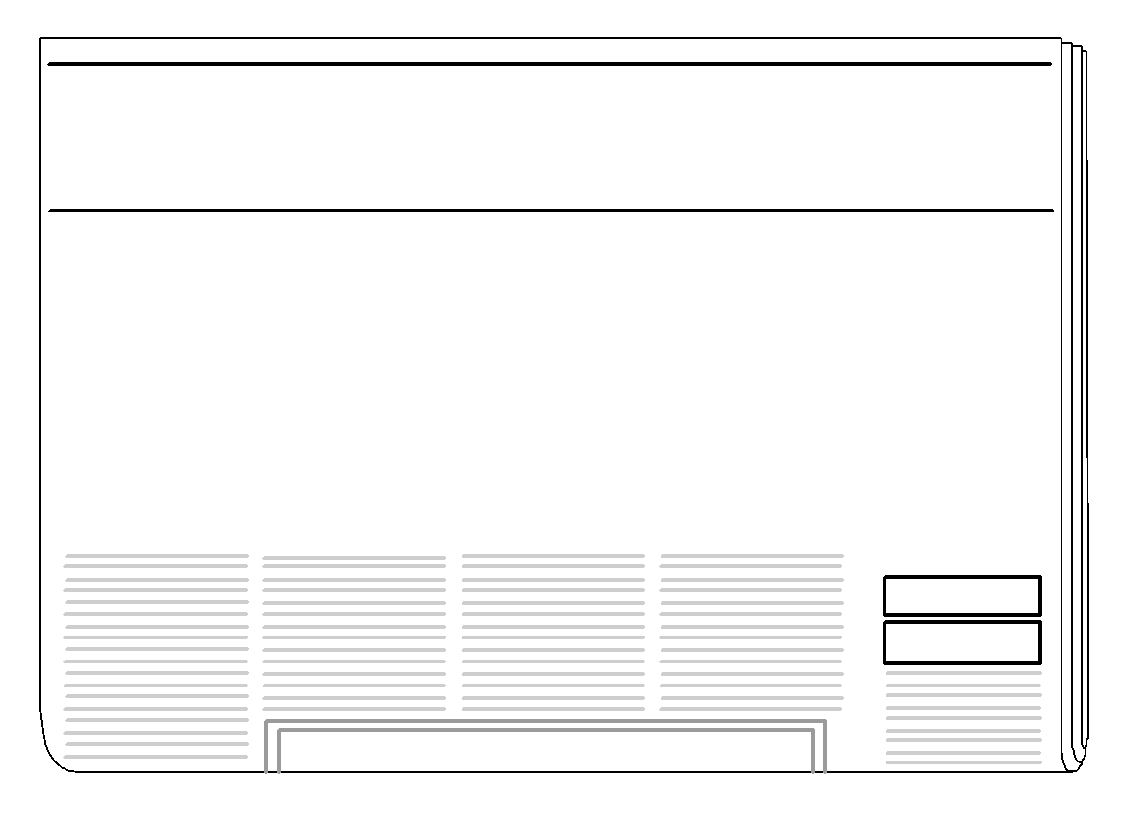
Help Wanted Classifieds

Biographer
Must be curious, well-organized, willing to conduct in-depth research, and an excellent communicator. Discover interesting characters and reveal fascinating facts! Apply today to begin an exciting adventure in the world of research and communication.

IN-CHARACTER SPEECH SHOWCASE
Applications for the 5th grade In-Character Speech Showcase are now being accepted!
The showcase involves the students in the selection and portrayal of a POSITIVE favorite character. The students are offered an unlimited array of POSITIVE character choices. Character representations may originate from film, literature, history, television, or theatre, as long as they portray a positive influence. The character may be real or fictional, from the past or present.

The students will present their speeches in the classroom. To guide the students in their preparation, we have outlined the following schedule:

April 13: All students must submit the name of the character they have selected. The chosen character must be approved by your child’s English teacher. (Characters that are inappropriate for representation at school will not be allowed.)

May 7: Notecards are due to ELA teacher.

May 21-May 23: Speeches in classrooms

May 24: An assembly to showcase the classroom speech winner. First, second, and third place winners will receive a trophy. All participants that make it to the assembly will receive a medal.

Participation is mandatory for all students. Students will work individually.

The expectation is ALL research is to be completed at home. The public library may be used. ALL computer labs at HHMS are occupied for the entire next month with state-wide testing. Outside research is required.

If the mention of an in-character speech suddenly makes your child look like this,
the following additional information may be helpful:

- The student will represent his/her character in both dress and speech.

- Participants are not permitted to offer food or prizes to judges or other students before, during, or after the speech.

- Speeches must be original: nothing copied from YouTube or Facebook, movies or television. Legal copyright rules apply.

- The speech should be between 3-5 minutes.

- No electronics allowed of any kind!!!

- Speeches should be well rehearsed. Note cards should be used only as a reference.

- We will assess the content and overall presentation of each speech. The students should review the following criteria to guide them in their preparation and practice:

Speech Composition:
- Write so people can understand you.
In a speech, the audience has only one chance to hear what you have to say. Avoid using long, complex sentences or a lot of facts and numbers.
- Use examples and stories that will paint pictures in the minds of your audience.
- Get off to a good start.

The opening to your speech should be an attention grabber. Capture the interest of your audience with an opening that stirs their interest in hearing more about your character.
- Write for feeling.
Select and write about a character that you can express with feeling.

- Your speech must be organized.
Stick to a few main points. Don't try to reveal every detail about your character. Explore each point fully before you move on to the next main point.
- Plan a strong ending.
Make your ending an interesting conclusion.
Speaking Skills:
- Rehearse your speech.
Before you present your speech, practice it often and out loud. Stand in front of a mirror or ask a family member to listen to it and give you helpful criticism.
- Body language is important. Show that you are excited about your character’s life and accomplishments.
Use good posture and appear confident. Avoid fidgeting with props.
- Establish eye contact.
Look at people in all sections of the audience. If you use a visual aid, point to the item but don't talk to it.
- No inappropriate joking or laughing.
- Vary your pace and volume.
Parents, please encourage and challenge your children to select an original character. We are always thrilled by presentations portraying “fresh” new characters.
-------------------------------------------------------------------------------------------------------------------------------------------

Character Selection Form

Due: Friday, April 13
Teacher Approval:
Yes_____
No _____

Student Name: ______________________________________
Character Name: _____________________________________
Parent Signature: _____________________________________

Three character traits to describe this person are: ________________________

_______________________ _________________________

